**FOR IMMEDIATE RELEASE:** April 22, 2013  
**CONTACT:** Akshath Sivaprasad, Student President, Science Infinity 425-502-9654, [akshath@live.com](mailto:akshath@live.com)

**Science Infinity Club and Chief Kanim Middle School host You Be The Chemist Challenge (YBTC)**

Fall City, Washington.—Can chemistry be made fun for the middle school students? Participants of the first ever Washington State *You Be The Chemist Challenge (YBTC) Challenge*® believe it can!

The *You Be The Chemist Challenge (YBTC) Challenge*® is an interactive academic competition, based on the National Science Education Standards. The Challenge engages students in grades 5 through 8 to learn important chemistry concepts through extensive study materials and activity guides while preparing them to take on Chemistry in high school and possibly pursue it as their career path! The challenge

* Introduce students to the central role of chemistry in all of the sciences & in their everyday lives
* Use the drama of competition to promote science, technology, engineering, and math education
* Provide educators with an exciting way to educate their students and assess their learning
* Encourage parents to participate in their child's education
* Allow industry members to connect with their community and actively show their support for science education

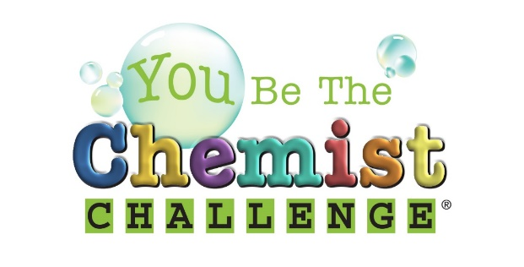

The inaugural Washington YBTC Challenge was held on April 20, 2013 and involved students from twenty five schools across King, Pierce, Snohomish and Thurnston counties. The Washington YBTC Challenge was sponsored by TRInternational Inc. and Univar. All the participants took a written test as a qualifier from which 30 students were selected for the electronic rounds. There were four electronic rounds each consisting of fifteen multiple choice questions. Students with lowest scores were eliminated at the end of each round.

In the final round, when only two participants were left, the format changed to oral round. Twenty questions were asked alternating between both students. Mr.Dunkel, principal from Chief Kanim Middle School (CKMS) hosted the final oral round.

Eshan Kemp, a 6th grader from Odle Middle School emerged as the state winner. First runner up was Mehek Dedhia, also a 6th grader from Odle Middle School followed by Rahul Chaliparambil (7th grade, Chief Kanim Middle School), Veenadhari Kollipara (7th grade, Jefferson Middle School) and Vishnu Rathnam (8th grade, Chief Kanim Middle School). Kemp won the competition answering all ten questions correct and Dedhia became the runner up answering seven questions correctly.Kemp will be traveling on expense-paid trip to Philadelphia for the National *You Be The Chemist* Challenge held on June 24th.

Mr.Dunckel said, “This is an exciting event and great opportunity for the kids to learn Chemistry, a critical subject that connects physics and biology”.

Mr.Henderson (science teacher at CKMS) and Ms.Fredenberg (math teacher at CKMS) along with Mr.Dunckel (Principal, CKMS) and Mr.Padisetty (Science Infinity club) partnered together in bringing the quiz style academic competition. Mr.Henderson said, “(The challenge) exposes the students to world of chemistry in a special way”. Sivaprasad adds that “… the event exemplifies the sort of partnership needed between the schools, parent volunteers and industry to make progress in the education system”.

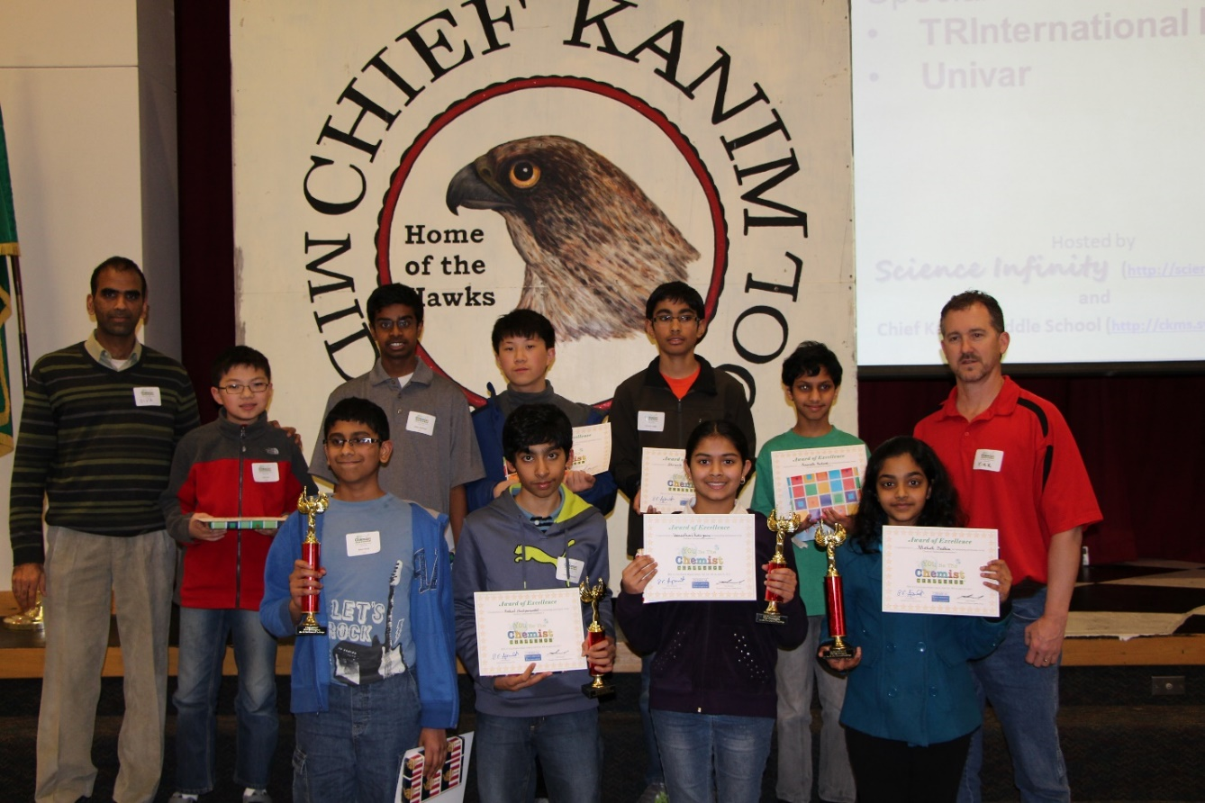

Pictured: (Back Row) Sivaprasad Padisetty, Kevin Mu, Vishnu Rathnam, Benjamin Mu, Dhruvik Parikh, Anirudh Prakash, Mr. Kirk Dunckel. (Front Row) Eshan Kemp (Winner), Rahul Chaliparambil, Veenadhari Kollipara, Mehek Dedhia (1st Runner-up).

More information about Science Infinity, CKMS and YBTC:

Science Infinity Club ([www.scienceinfinity.org](http://www.scienceinfinity.org)) is a non-profit organization formed to:

* Prepare students for academic excellence in science through coaching, on-the-go interactions and competitions with other like-minded students
* Develop young leaders by providing leadership roles and opportunities to achieve the current mission.
* Raise the standard of science education and research

Chief Kanim Middle School, part of Snoqualmie Valley School District, is the winner of Washington Achievement Award for four years (2009 through 2012) for overall excellence in Science and it is the only middle school in the state to receive science recognition for four straight years.

The YBTC Challenge was created by the [Chemical Educational Foundation® (CEF)](http://chemed.org/) to make chemistry fun.  CEF is a nationally recognized, award winning non-profit organization committed to enhancing science education among every generation, beginning with our youth. By emphasizing the central role of chemistry in all the sciences and in our everyday lives, CEF strives to inspire our future leaders in pursuing science-related careers and to improve the overall understanding of, participation in, and appreciation of chemistry and chemicals.